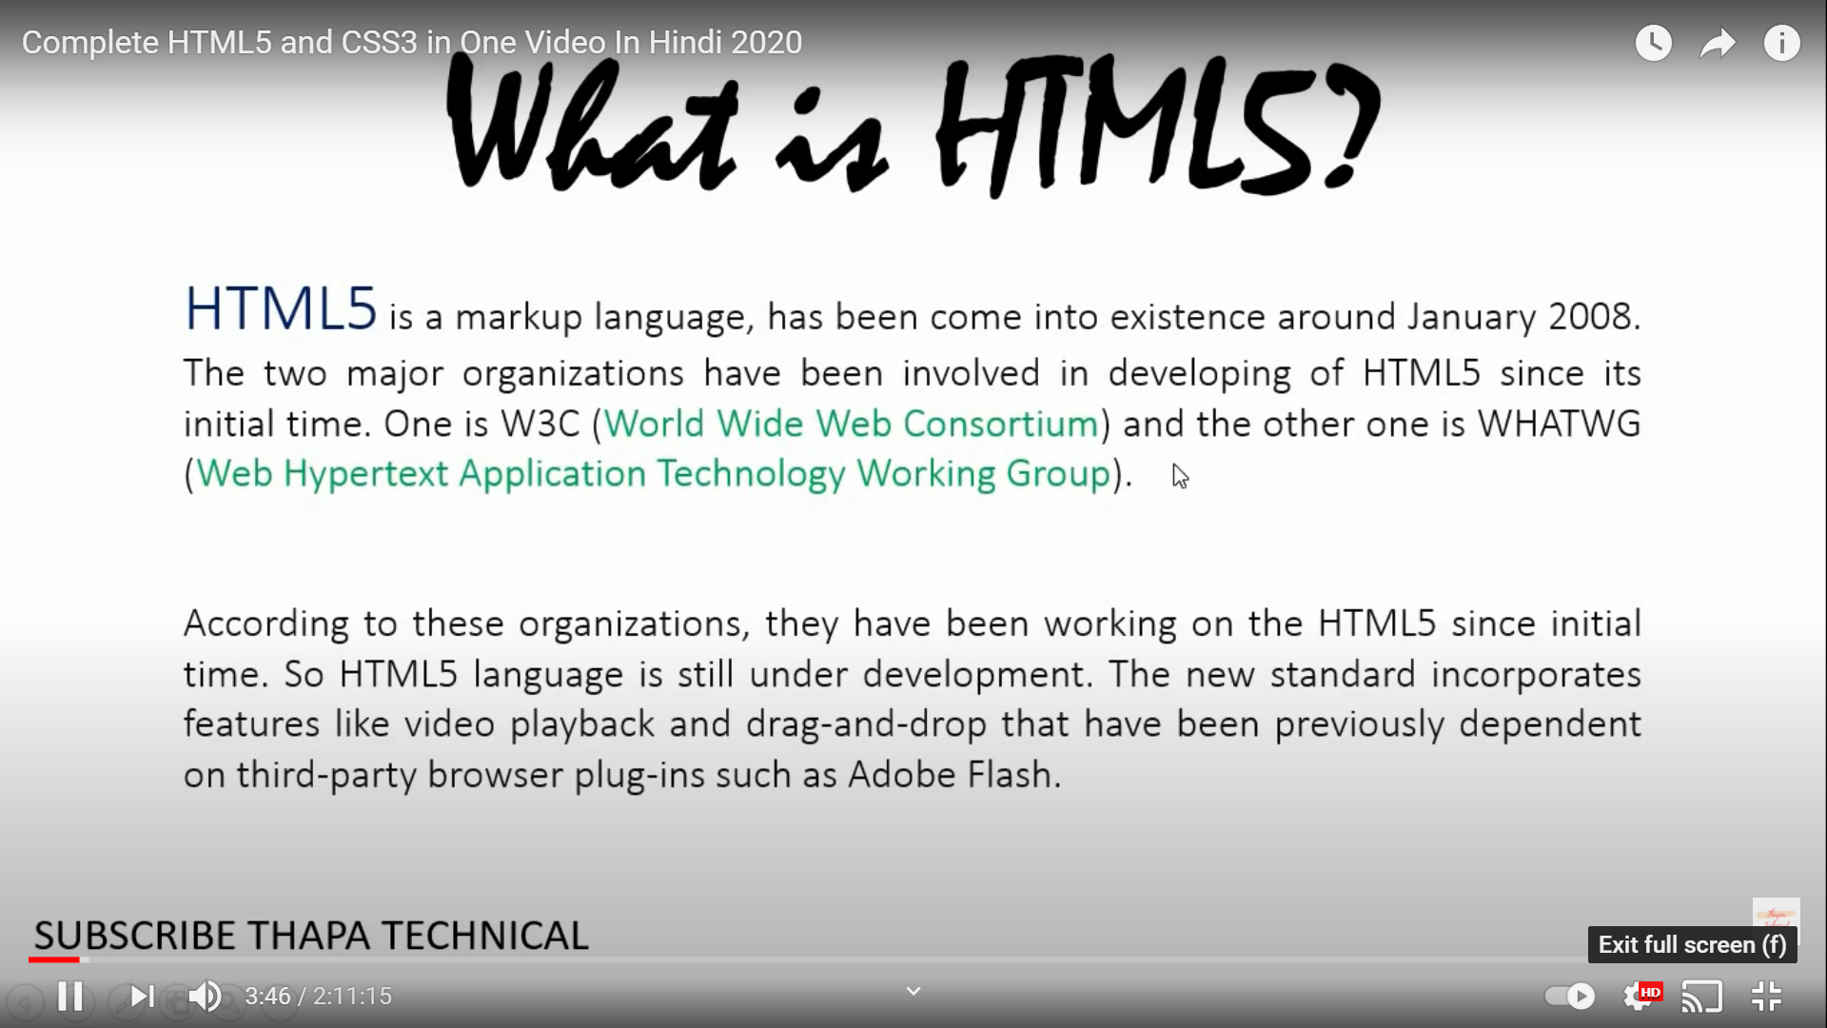

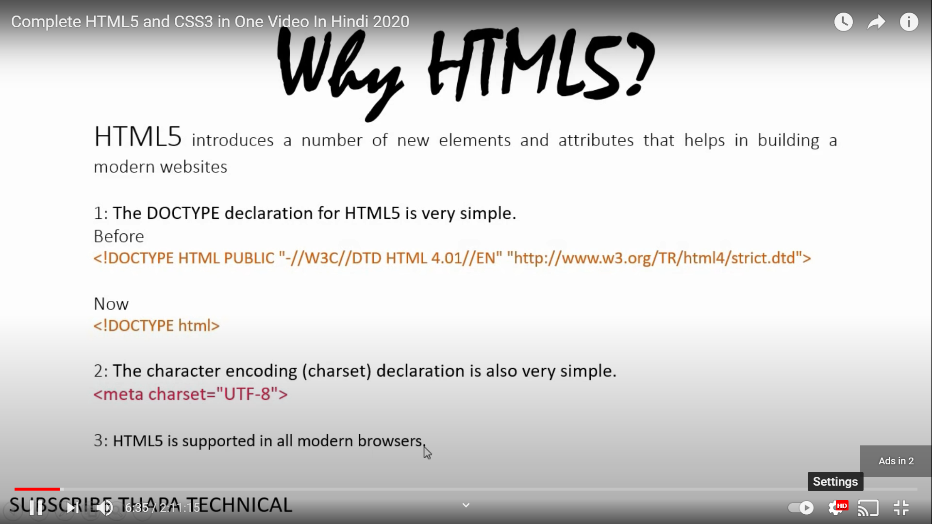

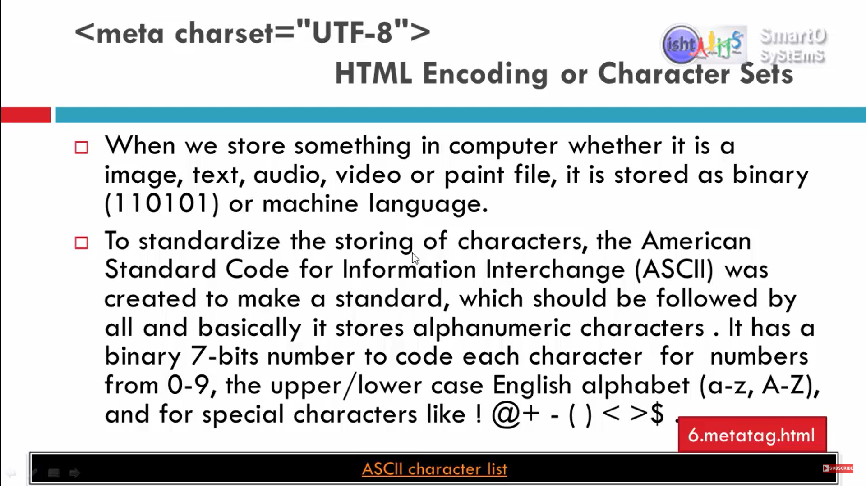

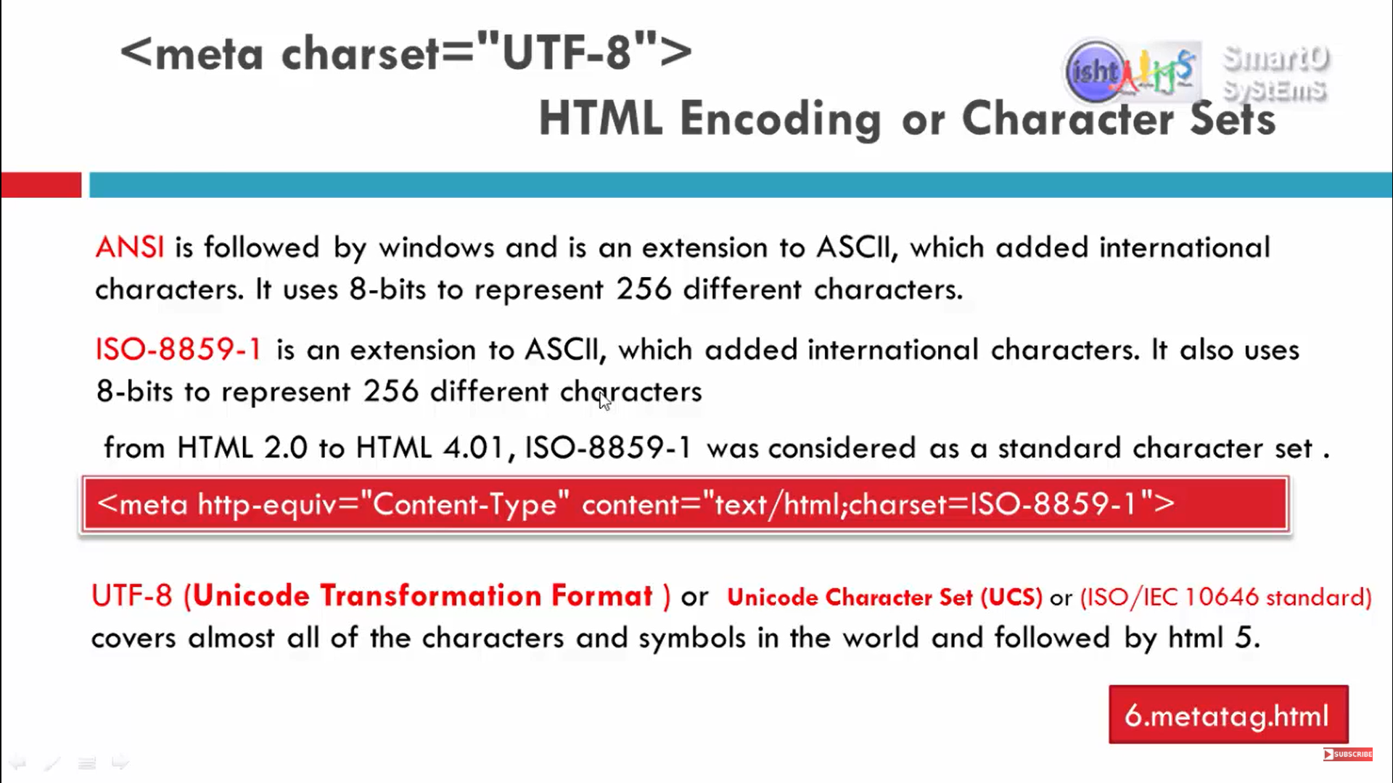

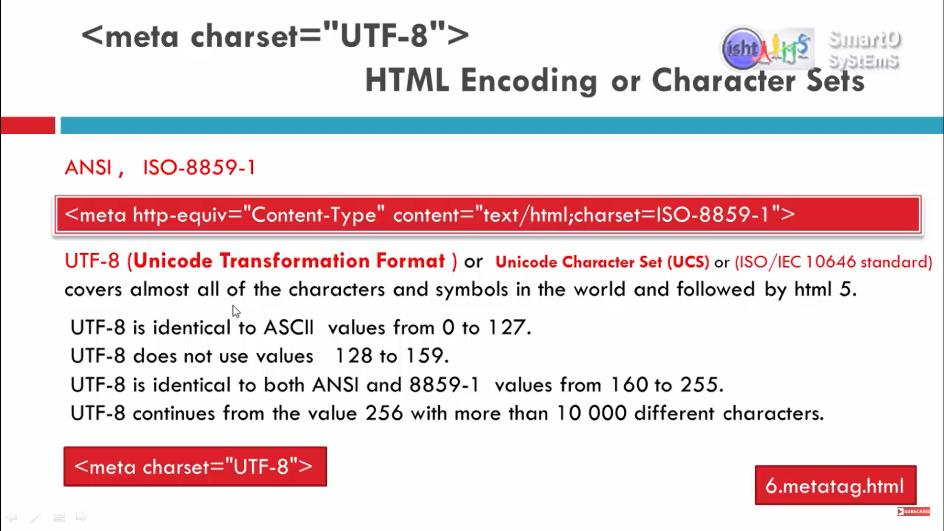

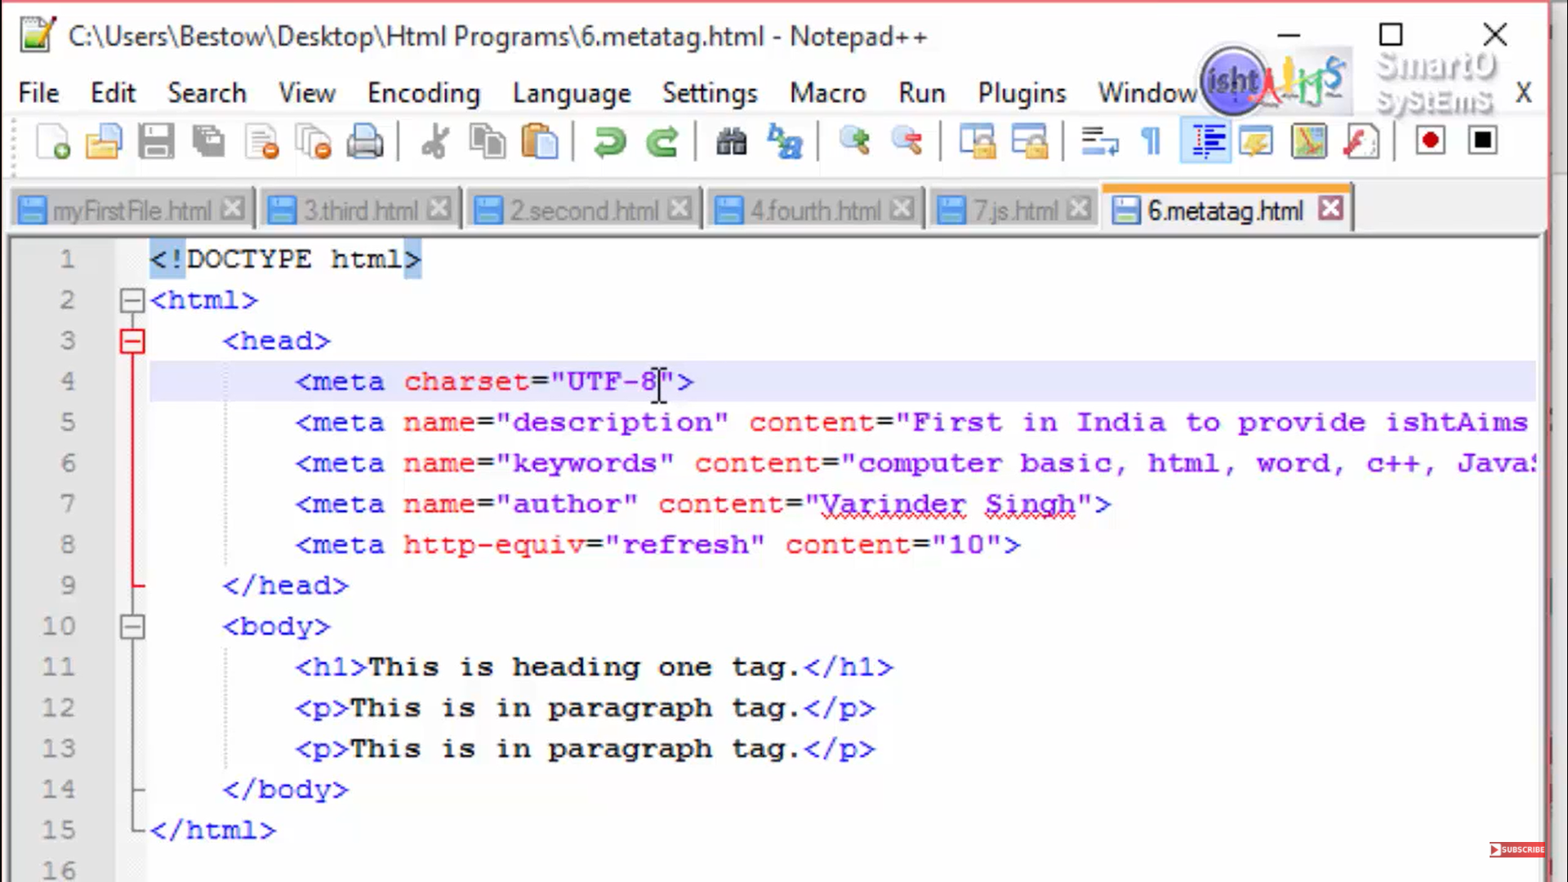

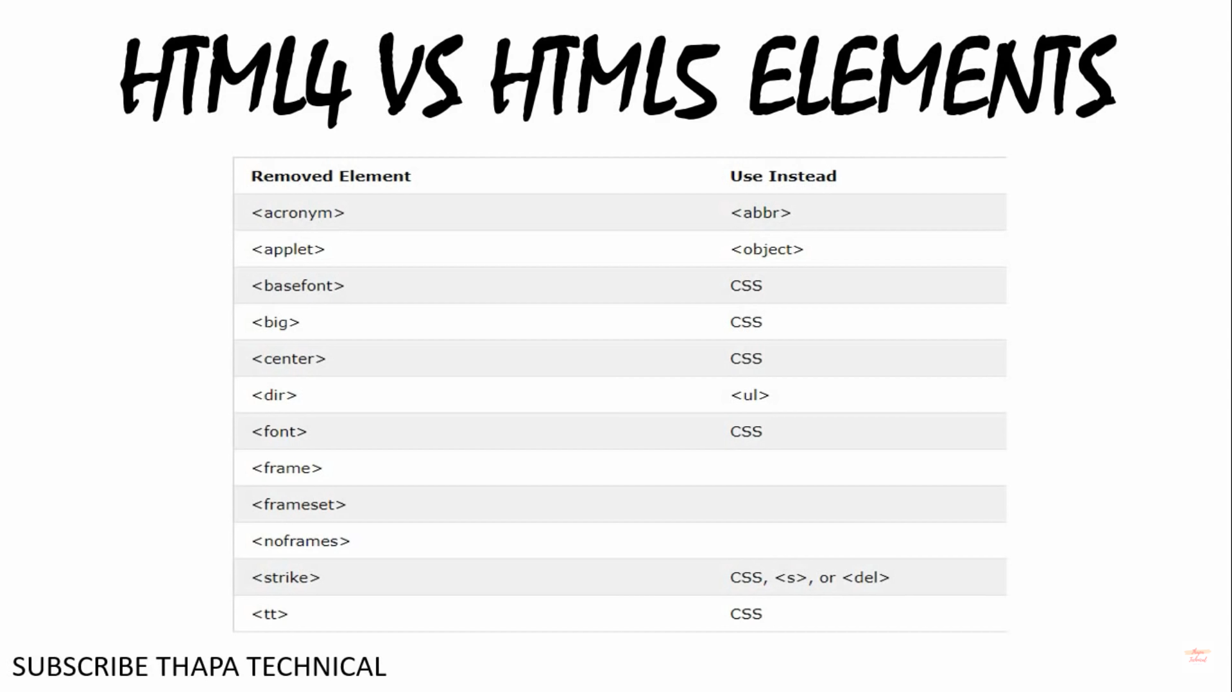

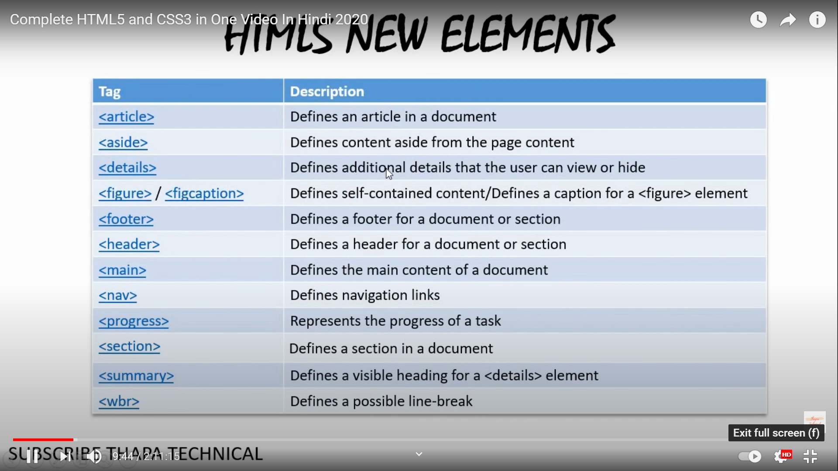

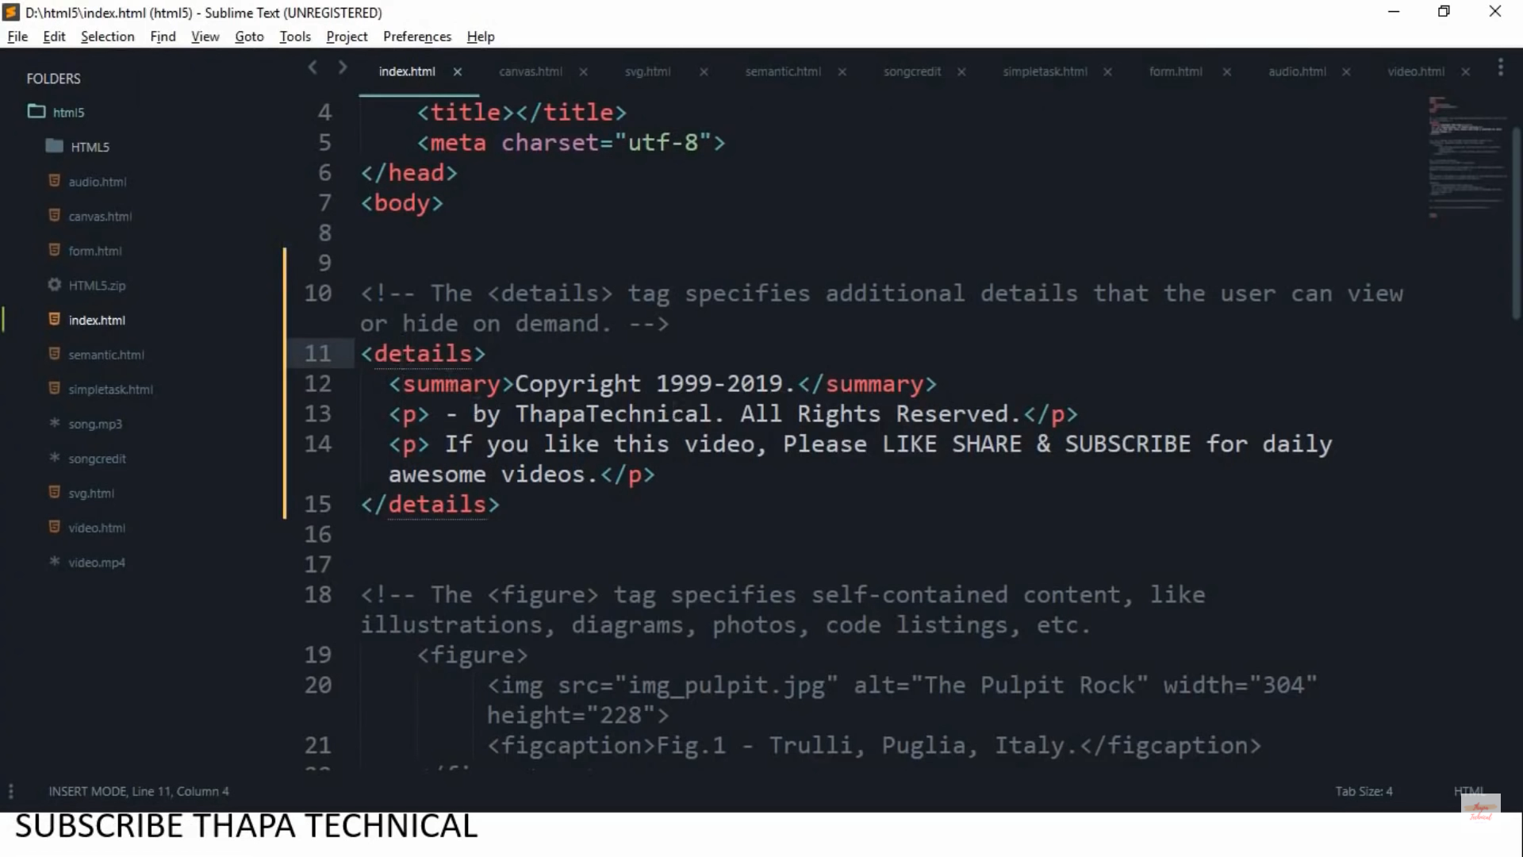

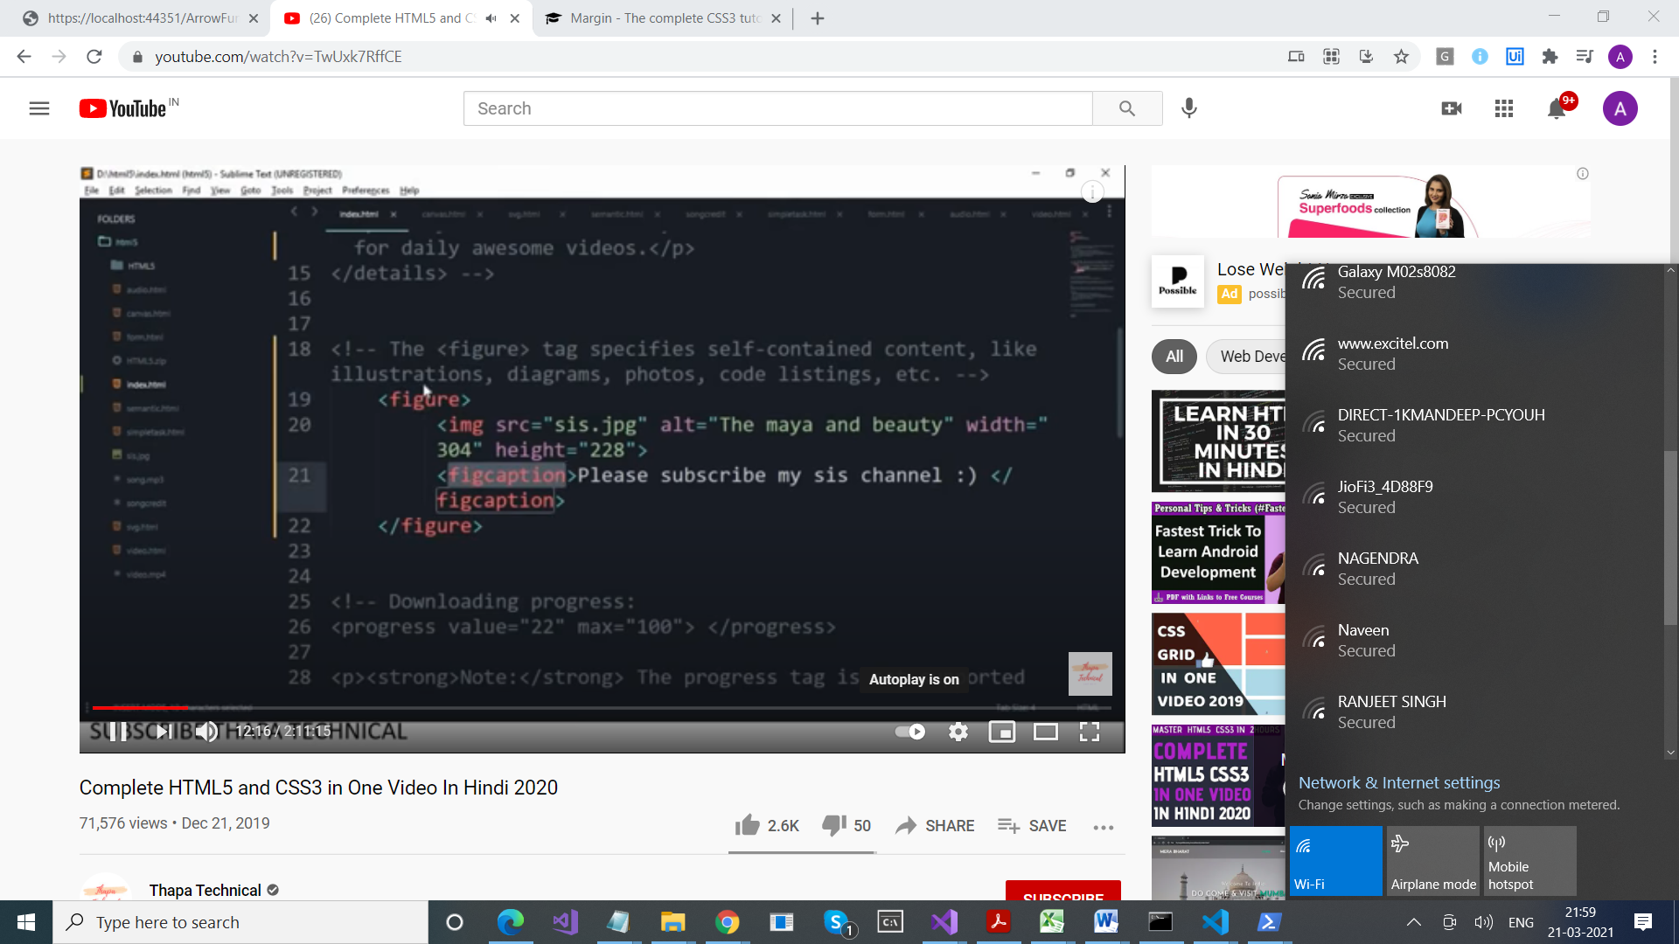

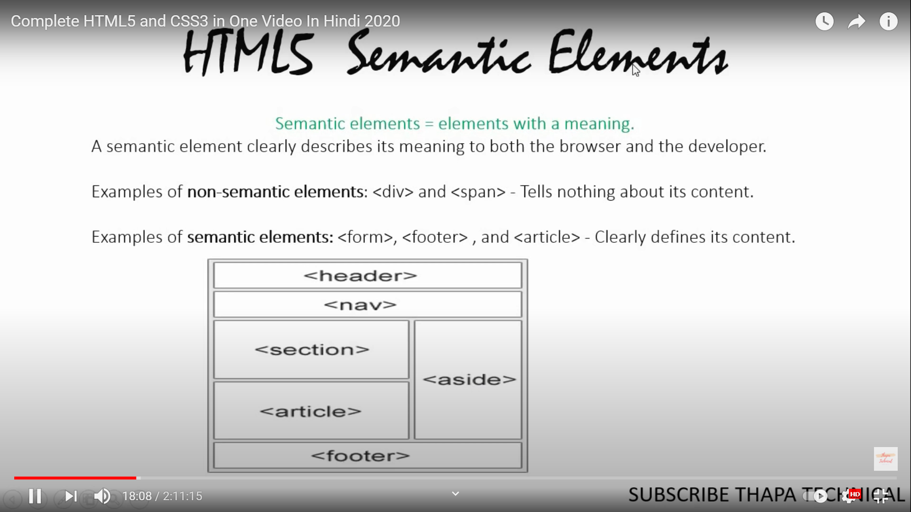

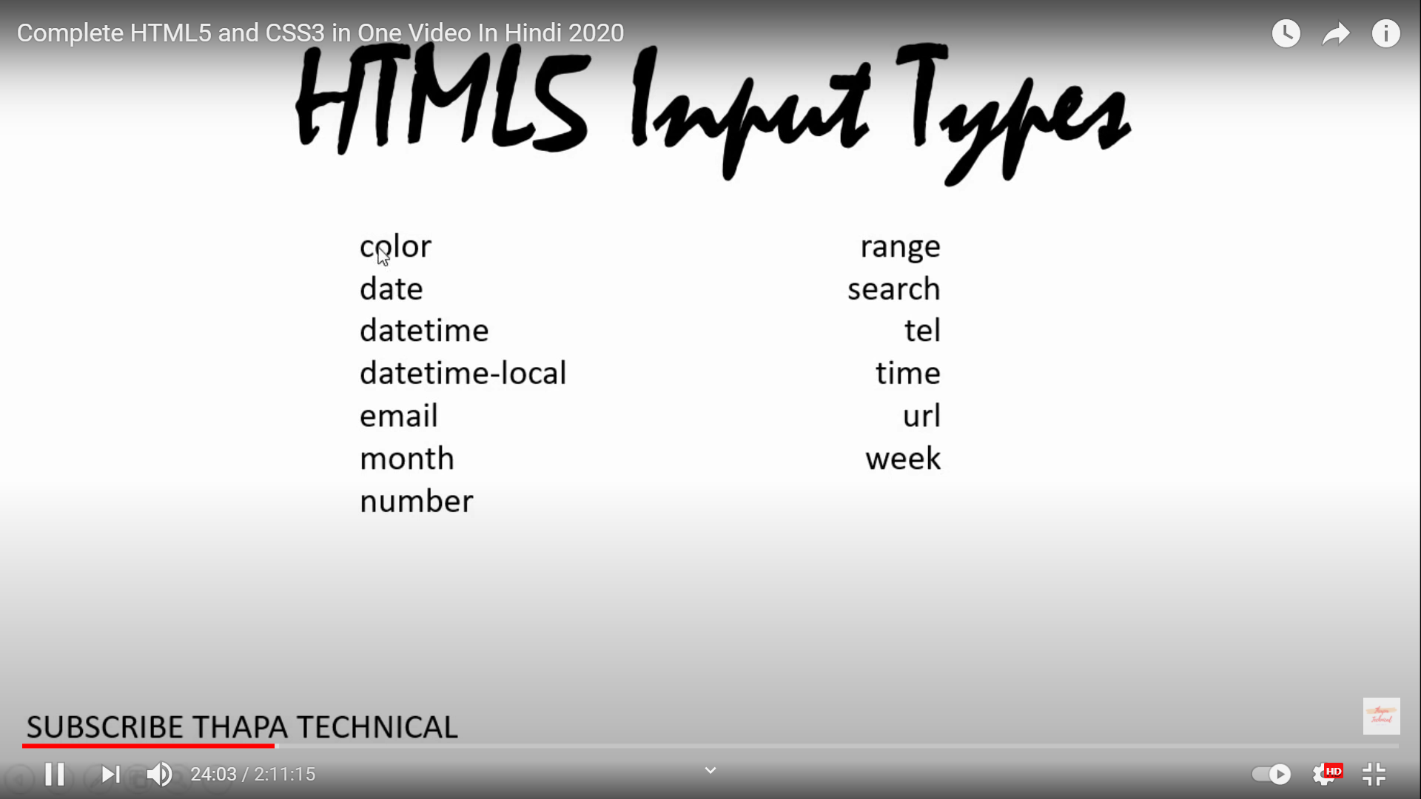

<!DOCTYPE html>

Doctype stands for Document Type Declaration. It informs the web browser about the type and version of HTML used in building the web document. This helps the browser to handle and load it properly.

All **HTML** need to have a **DOCTYPE** declared. The **DOCTYPE** is not actually an element or **HTML** tag. It lets the browser know how the document should be interpreted, by indicating what version or standard of **HTML** (or other markup language) is being used.

New Features of HTML5

Semantic Elements

### New types for input tags

<https://www.smashingmagazine.com/2019/01/html5-input-types/>

Canvas

canvas is a tag of HTML which is newly introduced in HTML5. It is used to draw the images on the fly. It can be used for visual images, rendering graphs, game graphics.

<canvas id="myCanvas"></canvas>

<script>

var canvas = document.getElementById("myCanvas");

var ctx = canvas.getContext("2d");

ctx.fillStyle = "#FF0000";

ctx.fillRect(0, 0, 80, 80);

</script>

**. Video and Audio**

Video and audio are the new tags which allow to embed a video in the website. YouTube also declare video embed by giving the code to embed for their videos. It helps the web to be more involved with multimedia. A new tag is also available in HTML5 and that is audio tag. Which is used to embed any audion in the web.

**Example of using Video tag**

<video controls preload>

    <source src="cohagenPhoneCall.ogv" type="video/ogg; codecs='vorbis, theora'" />

    <source src="cohagenPhoneCall.mp4" type="video/mp4; 'codecs='avc1.42E01E, mp4a.40.2'" />

    <p> Your browser is old. <a href="cohagenPhoneCall.mp4">Download this video instead.</a> </p>

</video>

**Audio**

<audio autoplay="autoplay" controls="controls">

 <source src="file.ogg" />

    <source src="file.mp3" />

    <a>Download this file.</a>

</audio>